THE TITLE OF THE PAPER

First A. AUTHOR¹, Second B. AUTHOR², and Third C. AUTHOR¹
¹ Institution of the first and third author

² Institution of the second author

ABSTRACT
This template provides information for the authors to prepare their final paper for the sixth edition of International Conference on Structural Health Assessment of Timber Structures – SHATIS´22. The expected length of this abstract section is 8-12 lines (maximum 200 words). The main idea and work that has been done should be described, followed by a short summary of the findings. The content should be presented in a clear and straightforward manner in order for the topic to be easily understood and to allow the organizers to recognize that it matches the scope of the conference. The authors are encouraged to be accurate and specific so that the abstract is sufficiently representative of the paper within the word count limit.

KEYWORDS: 3-5 keywords, separated by commas

INTRODUCTION
The paper is to be written following these instructions, preferred is using this Word template. Also, the deadline for uploading, which is published on the conference website, must be respected. The paper should be written in English, including the labels and legends in the figures. It must have a minimum of four pages and the first one must contain the title, author(s), their affiliation(s), keywords and a short abstract. The rest of the paper should describe in depth all details of the research. Expected length of the final paper should be 4-6 pages. A nice overview of good publishing practice can be found in [1], however, the style of references should be the ones described in [2].

METHODOLOGY
All the texts in the paper should be written using Cambria font style. The title of the paper, as well as all the headings, are all capital boldface letters.
The title is to be left-aligned, written in 16 pt and 1.15 spaced if it is longer than one line. There is a 42pt space before and a 10pt space after the title text. The list of the authors and their affiliations follows the title. It should be written in 11pt font (boldface for authors line), left-aligned and 1.15 spaced. There is a 6pt space after each row.
The headings are left-aligned, written in 11pt font and there should be a 6pt space both before and after the heading. Keyword row counts as a heading. All the plain texts should be justified and written in 11pt Cambria without any extra space before or after the paragraph. Spacing for both headings and plain texts is 1.15.
Schemes, equations, illustrative pictures or tables may be an essential part of the abstract. The captions (e.g. Table, Figure) should be written in 10pt font style using Italics and 1.15 spacing. There should be a 6pt space before and after the caption line which should be centred. All inserted elements must be numbered consecutively using Arabic numbers according to their type. For equations use numbers in parentheses at the end of the equation line. Figure captions should be placed below the figure, and table captions before the table. Images are required to have a resolution of at least 300 dpi, and should be less than 300 kB in size. Compression of pictures should be avoided, as it is in this template. See Table 1 for the table styling. Equations should be centred and separated from the surrounding text by a 6pt space before and after the line. Explanations are required for any symbols used in formulas. References should be formatted as described in [2] (Style 1).
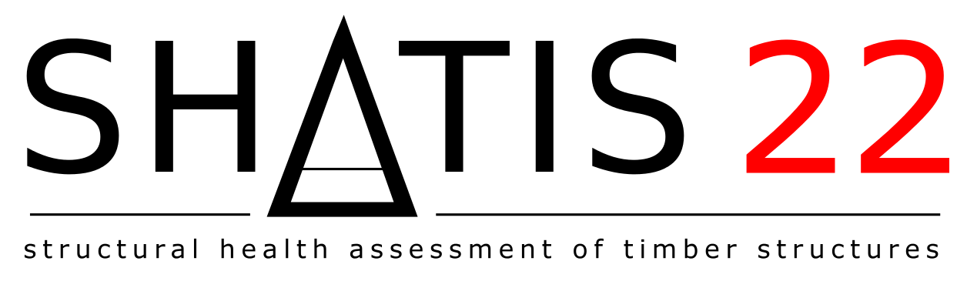
Figure 1: Figure example – the conference logo of SHATIS’22
RESULTS
Results will be presented here. Unlike in the extended abstract version please provide as much graphics and data as is needed.
Table 1: Important dates
Action | Date
Abstract submission | April 15, 2022
Notification of acceptance | April 29, 2022
Full-text submission | May 31, 2022
Revised full-text submission | July 10, 2022
Conference | September 7 – 9, 2022

DISCUSSION
Please provide also discussion and critical evaluation of the results.

CONCLUSION
Papers should be submitted electronically by using the conference website and registration system (a new submission type is available). The authors of the papers will be contacted after review to finish the whole process and after this step the final version will be submitted (until July 10). Expected formats of the final submission will be both PDF and a M$ Word .docx file (for the case we need some corrections). If somebody uses other word processing software, please contact us via mail, we can find a solution.

REFERENCES
[1] EFM Paper writing standards. how to write a scientific article - Engineering Fracture Mechanics - ISSN 0013-7944 (elsevier.com), accessed 28.4.2022.
[2] Elsevier numbered standard reference style. https://booksite.elsevier.com/9780081019375/content/Elsevier%20Standard%20Reference%20Styles.pdf, accessed 20.1.2022.

