THE TITLE OF THE PAPER

First A. AUTHOR¹, Second B. AUTHOR², and Third C. AUTHOR¹
¹ Institution of the first and third author

² Institution of the second author

ABSTRACT
This template provides information for the authors to prepare their extended abstract for the sixth edition of International Conference on Structural Health Assessment of Timber Structures – SHATIS´22. The expected length of this abstract is 8-12 lines (maximum 200 words). The main idea and work that has been done should be described, followed by a short summary of the findings. The content should be presented in a clear and straightforward manner in order for the topic to be easily understood and to allow the organizers to recognize that it matches the scope of the conference. The authors are encouraged to be accurate and specific so that the abstract is sufficiently representative of the paper within the word count limit.

KEYWORDS: 3-5 keywords, separated by commas

INTRODUCTION
The paper is to be written following these instructions, preferred is using this Word template. Also, the deadline for uploading, which is published on the conference website, must be respected. The paper should be written in English, including the labels and legends in the figures. It must have a maximum of two pages as the first one must contain the title, author(s), their affiliation(s), keywords and a short abstract. The rest of the paper should give the scientific committee the idea of the research. An extended abstract is a research paper whose ideas and significance can be understood in less than an hour of reading [1]. It contains the references, but e.g. the future work or very specific details of the tests are omitted.

METHODOLOGY
All the texts in the paper should be written using Cambria font style. The title of the paper, as well as all the headings, are all capital boldface letters.
The title is to be left-aligned, written in 16 pt and 1.15 spaced if it is longer than one line. There is a 42pt space before and a 10pt space after the title text. The list of the authors and their affiliations follows the title. It should be written in 11pt font (boldface for authors line), left-aligned and 1.15 spaced. There is a 6pt space after each row.
The headings are left-aligned, written in 11pt font and there should be a 6pt space both before and after the heading. Keyword row counts as a heading. All the plain texts should be justified and written in 11pt Cambria without any extra space before or after the paragraph. Spacing for both headings and plain texts is 1.15.
Schemes, equations, illustrative pictures or tables may be an essential part of the abstract. The captions (e.g. Table, Figure) should be written in 10pt font style using Italics and 1.15 spacing. There should be a 6pt space before and after the caption line which should be centred. All inserted elements must be numbered consecutively using Arabic numbers according to their type. For equations use numbers in parentheses at the end of the equation line. Figure captions should be placed below the figure, and table captions before the table. Images are required to have a resolution of at least 300 dpi, and should be less than 300 kB in size. See Table 1 for the table styling. Equations should be centred and separated from the surrounding text by a 6pt space before and after the line. Explanations are required for any symbols used in formulas. References should be formatted as described in [2] (Style 1).
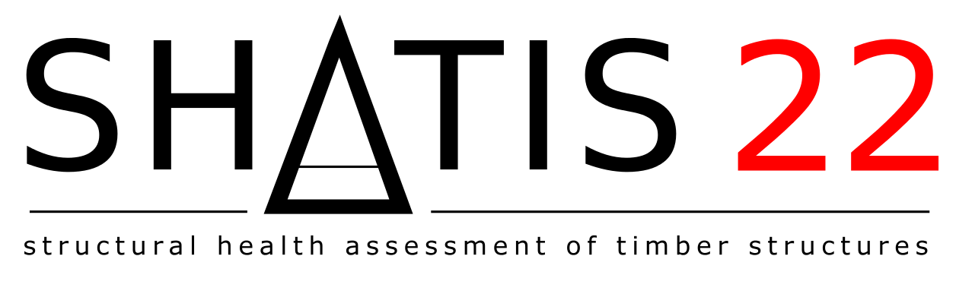
Figure 1: Figure example – the conference logo of SHATIS’22
RESULTS
Results will be presented and discussed here. Due to the limited space in the abstract, avoid using too much graphics here; the section can be enriched more in the full-text version. Actually, it is advisable to use the abstract after acceptance to produce the final full-text (4-6 pages) version. Consider this point while preparing the abstract.
Table 1: Important dates
Action | Date
Abstract submission | March 18, 2022
Notification of acceptance | March 31, 2022
Full-text submission | May 15, 2022
Revised full-text submission | June 30, 2022
Conference | September 7 – 9, 2022

CONCLUSION
Papers should be submitted electronically by using the conference website and registration system. The authors of the accepted papers will be informed via e-mail by the end of March 2022 so they can begin preparing their full-text paper.

REFERENCES
[1] Pugh, W., Advice to Authors of Extended Abstracts. http://homepage.cs.uiowa.edu/~tinelli/classes/Common/papers/advice-authors.pdf, 1993, accessed 22.01.2020.
[2] Elsevier numbered standard reference style. https://booksite.elsevier.com/9780081019375/content/Elsevier%20Standard%20Reference%20Styles.pdf, accessed 20.1.2022.

